It is used to check that a device A is connected to another device B over internet or not.

The ICMP protocol is used in this.

The device A sends ICMP-request to the device B if it successfully reaches to the device B then the device B sends ICMP-reply to the device A.

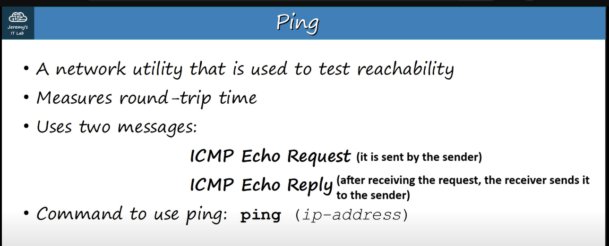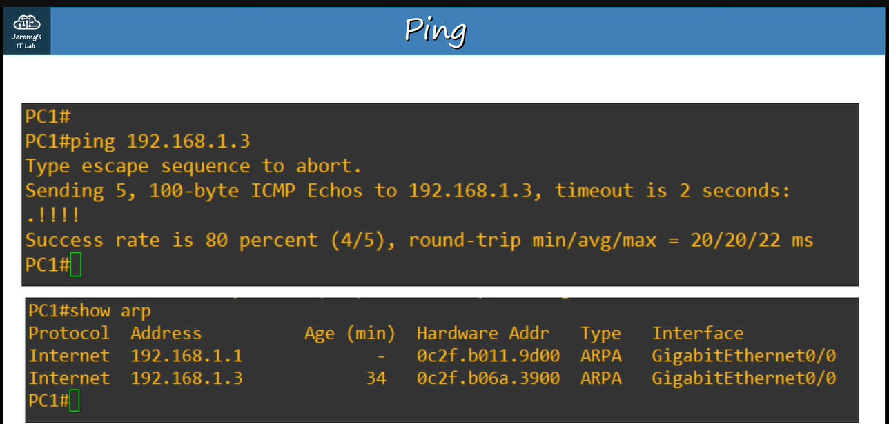

Both ICMP-request and ICMP-reply are unicast.

If you run ping command first time then first ICMP-request is lost because the ARP-request is sent and ARP-reply is received b your computer.